## Ethical, moral and legal issues



I have put a disclaimer in the footer on each page to recognise all images and icons that I have sourced off other websites.

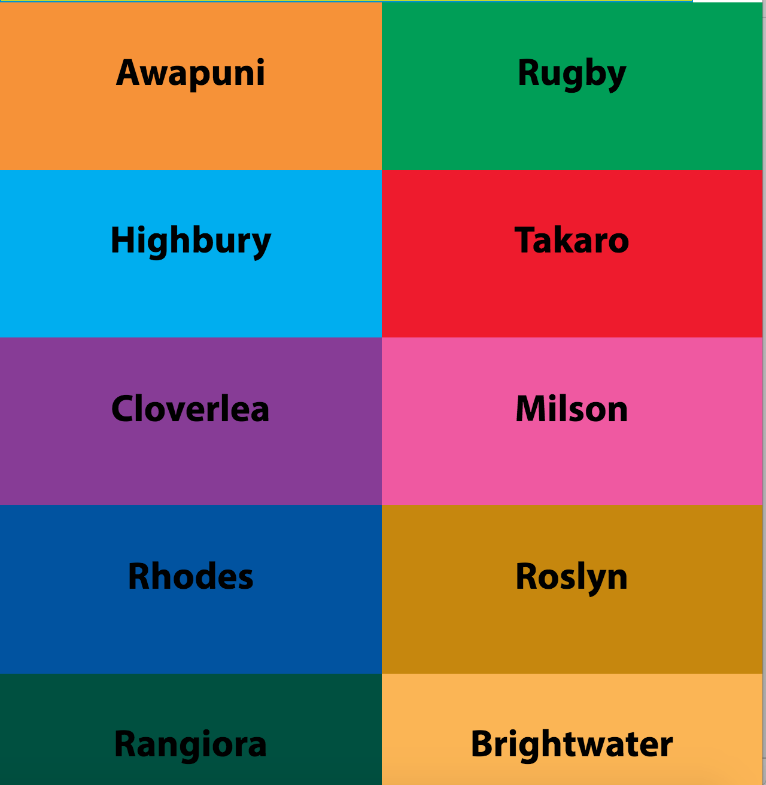

I have made the app suitable for users of all ages. I have used larger fonts and buttons to make ease of use to people who may have difficulty seeing smaller text, I have done this to make the app usable for people of all ages as they are able to see what the buttons are for and they are easily clickable.

The app will never ask for any personal information about the user. The only thing that the app will ever ask you for is information on where you would like to go. This will be stored on the device that the app is running on so that no one else will be able to access this data.

Location tracking is used to get the location of the user to show where the nearest bus stop is. This information is used and not stored in the data as it is only needed for the time that the user us searching for the stop near them.

## Accuracy and testing

I have ensured accuracy of my app through large amounts of testing. Each page is tested for user faults as it is coded, therefore finding any difficulties that the user might have. Some of the errors that I have come across so far are:

* Not having a back button on each page
  + I fixed this by going through each page whether the page had been coded yet or not. Which then meant that all pages had a back button that was linked to the previous page.

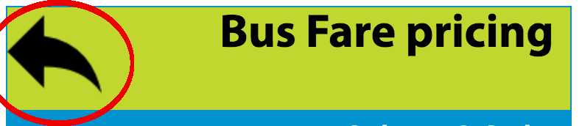

* Having information in a different order on the page for website vs app
  + 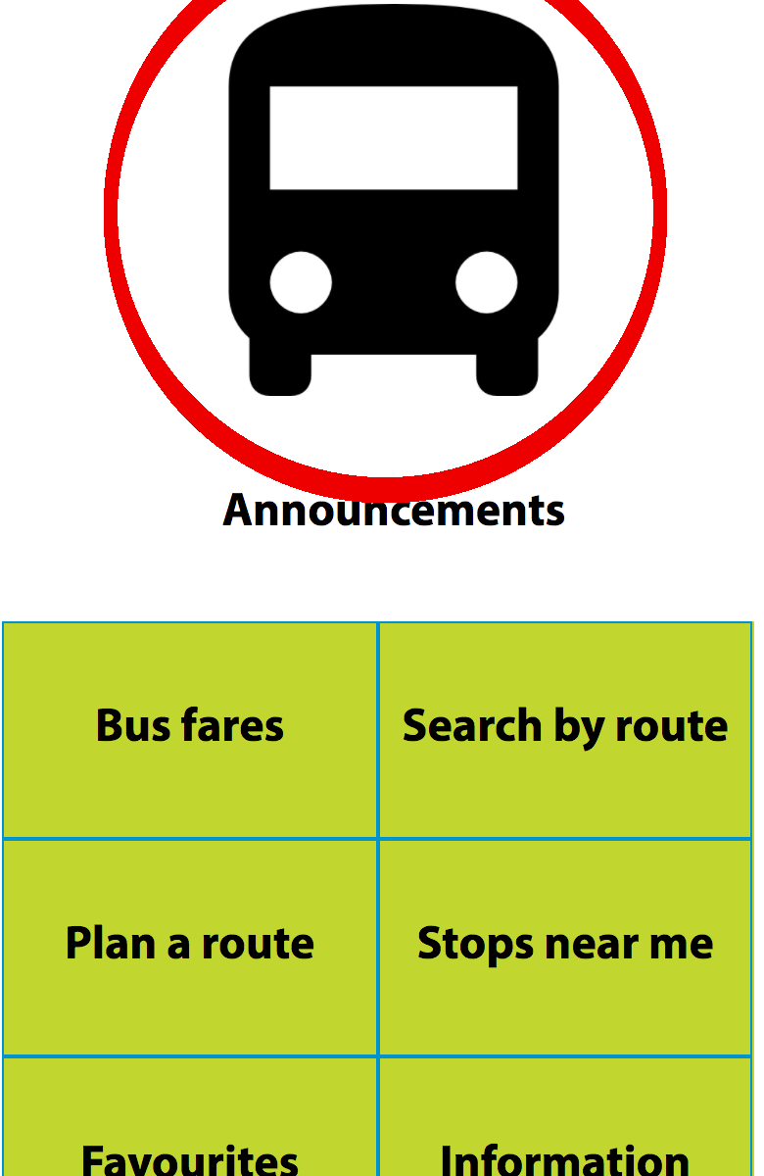I solved this buy adding the information again in the space the order that I would like it, and then adding styling to it so that it was in the correct position on the page and not on the page more than once

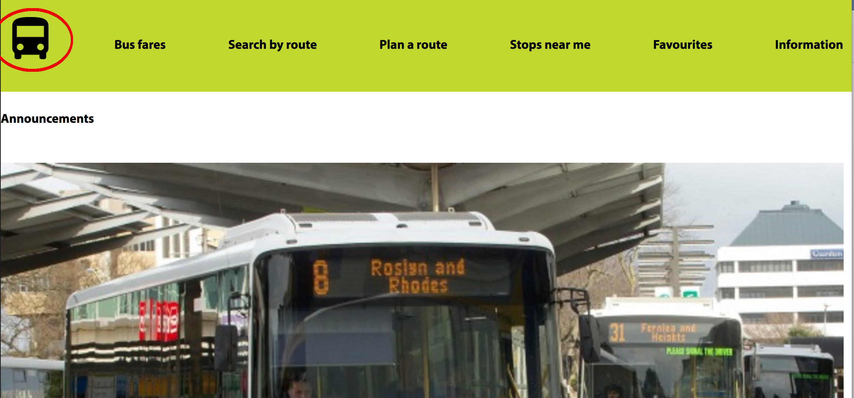

Web VS Mobile

* Objects that do not line up properly on the page
  + I used CSS to add individual styling to each element that was out of place. And then made sure that when the page size was changed that it remained in the correct positions.

I made sure that there were no errors in the content of the pages as I typed the information straight from the Horizons Bus Timetable booklet on to Microsoft word so that any spelling and grammar issues were picked up straight away, I edited the Information so that there were no spelling or gramma issues. Then copied the text to the HTML document. This meant that there were no errors in spelling. I then proofread the information on the webpage display so that it would read correctly to the user.

I have used a code validator to make sure that there are very little to no errors in my code. Whilst doing this the main error that occurred was that there were no alt tags on images, so I went through and added alt tags to all of my images. Other small errors that occurred were fixed and all pages are now error free.

The CSS page was also validated and came back with no errors to be found.

## Efficiency

I have saved time when creating this app through using copy and paste of the base code on to each HTML page.

I also copied the routes as all the pages were the same apart from button titles and the timetables that are hidden under the buttons.

I saved time by making the CSS all on one page so that if I wanted something to be an h1 then the styling was already done, this saved time and let me see exactly what the writing would look like as a h1 straight away.

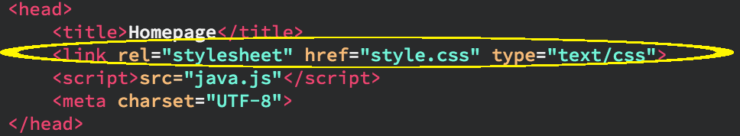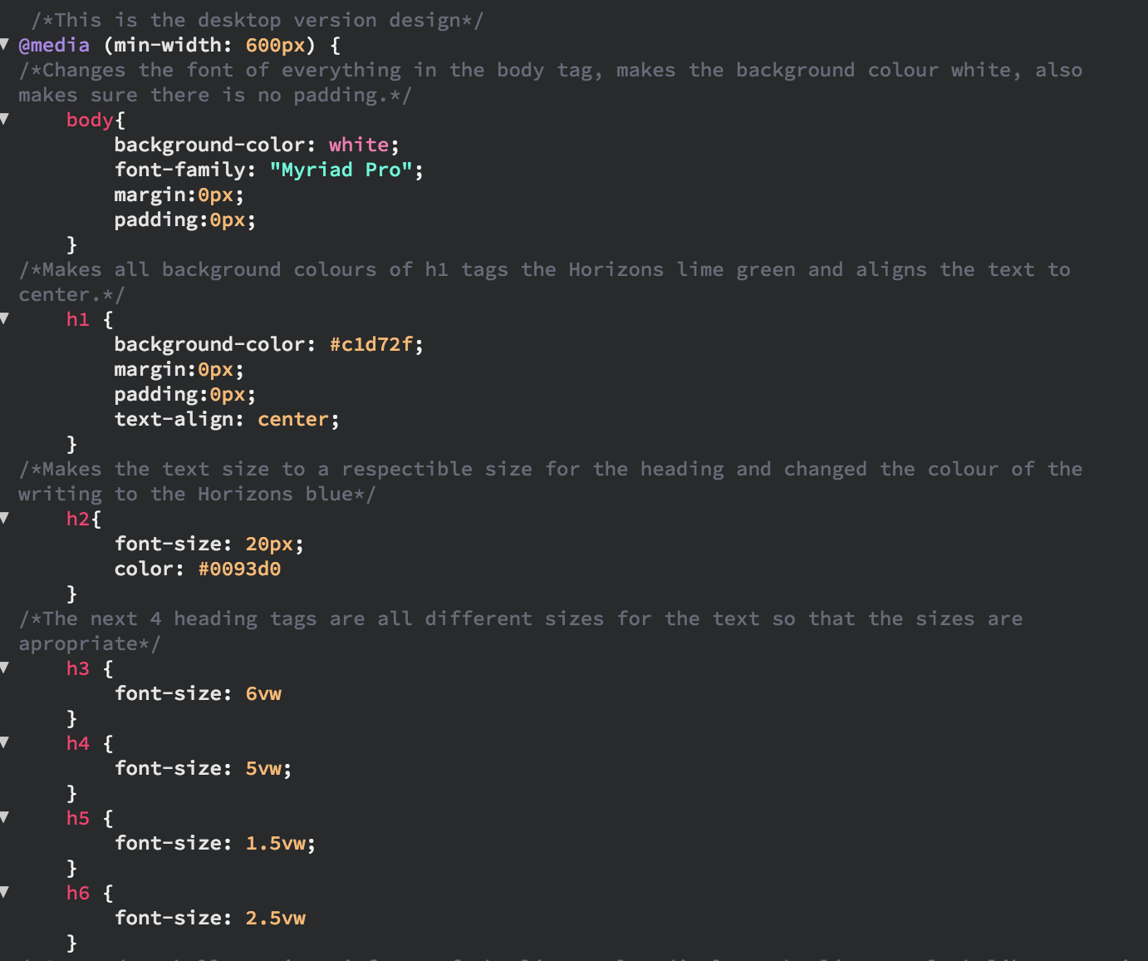

I also saved time by commenting the code as I went so that I knew what attribute did what without having to play and figure it out.

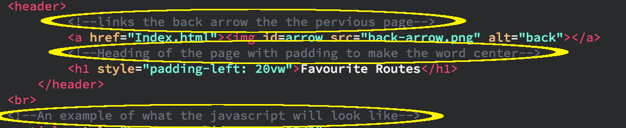

I also saved time by using HTML-5 semantics rather than having a lot of div’s. This meant that everything was grouped appropriately as well, also that there was no need to style each div, all I had to do was style the semantic tag.

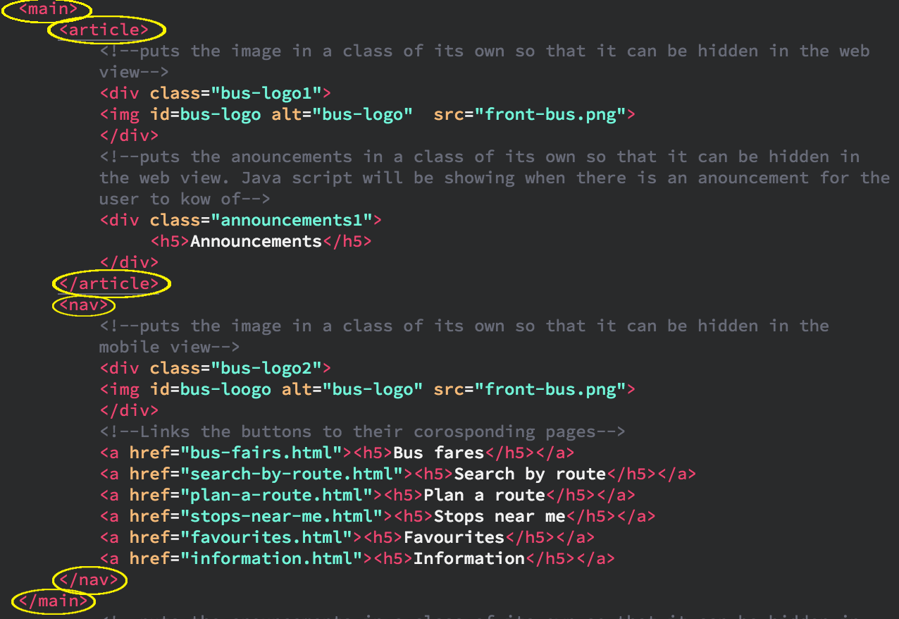

I used the control click feature to edit in more than one place at once therefore saving time by not having to write or find everything each time I wanted to change something, to make this even faster I used find and replace to find all of one tag that I wanted to change to something different in the document

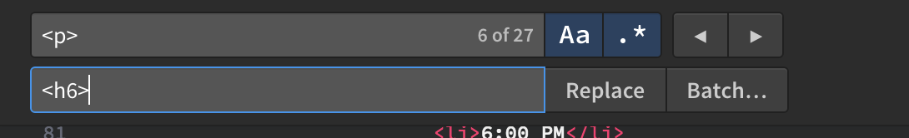

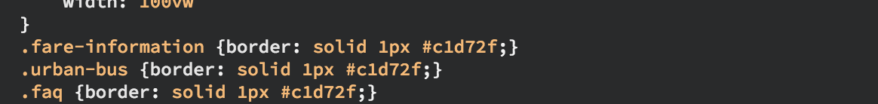I made the CSS more compact by changing those with all the same styles to be on the same line.